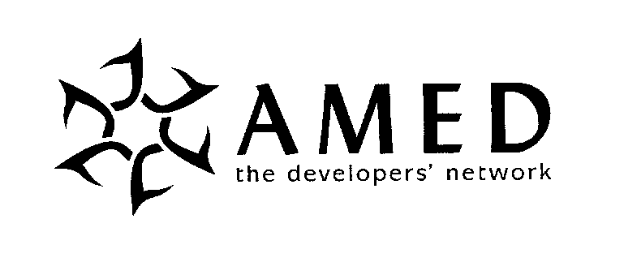
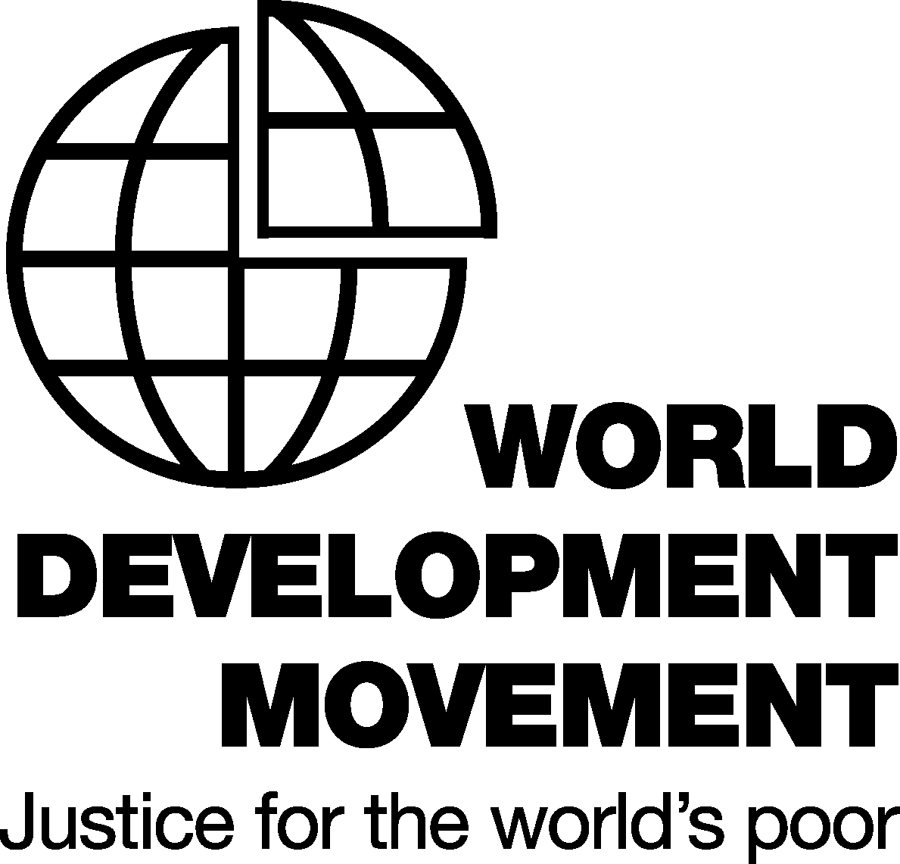

An AMED FORUM

GLOBALISATION AND ITS IMPLICATIONS FOR BUSINESS IN SOCIETY

Wednesday, 16th APRIL 2003, 4-30 to 7-00pm.

Speaker: Barry Coates
Director of the World Development Movement

Facilitator: Bruce Nixon, AMED Council Member, consultant and author of “Global Forces – A Guide for Enlightened Leaders – What Companies and Individuals can Do” and “Making a Difference - Strategies and Tools for Transforming your Organisation”

AMED is pleased to host an innovative and participative forum on the challenges facing leading businesses in the global economy. Barry Coates will introduce the evening with a provocative analysis of the economic, ethical and environmental crisis facing much of the world.

Participants will have opportunities for questioning, discussing and shaping a coherent response at the personal, organisational and societal levels. The focus will be on how we can play a role in shaping organisations that we and our children will feel proud to work within and also what individual citizens can do.

Venue: London School of Economics, details below
Time: 4-30 to 7-00pm
Cost: AMED Corporate rate and non members £50-00; other AMED Members and WDM Members £30-00; Concessions for Charities and people on low incomes £15-00; £5-00 for students and unwaged.

This is a joint event with the World Development Movement. AMED, a not for profit charity providing a network for people in OD and Leadership Development, would like to recognise the contribution of the WDM towards resolving global issues by sharing the proceeds of this meeting to enable them to continue their good work.

Outline of the issues The past few decades have seen dramatic changes to the fundamental parameters within which business operates. In response to technological change and the de-regulation of the international economy, business leaders have faced the challenge of international competition by fragmenting supply chains and production systems, often scattering value added functions across the globe. In response to increasing societal concern over the impacts of globalisation, business leaders have embraced the language and some of the practices of ethical and environmental business. And in response to the changing demographics of their staff, business leaders have adapted their organisations and developed flexible working to meet the diverse needs of different members of society.

But these responses have not removed the underlying structural problems. Business is under scrutiny and challenge as never before. We face global crises of poverty, climate change and terrorism; financial fraud and instability as exemplified by Enron and repeated financial crises amongst the emerging economies; and a crisis of confidence in the leadership of businesses and governments that has alienated employees and voters alike. These crises will sharpen the divide between the winners and the losers, for nations, organisations and individuals.

Yet we are not powerless. Far from it. It is the actions of us all that are shaping the world in which we live. And there are a multitude of inspiring examples of change, often at the micro-level, that give rise to optimism that people can change, new forms of organisations can emerge and international rules can be fair and sustainable.

The purpose of the event is to increase understanding of the challenges and the opportunities, and to provide the space for participants to reflect on what they may want to do as directors, managers, consultants and individual citizens. The event will take the form of a forum that will be more interactive and participative than a standard talk; a dialogue that allows for discussion in smaller groups around key themes; and enables people to share their thinking and what they are already doing and intend to do.

There will be time for networking before and after the event.

Barry Coates is Director of the much respected campaigning network, the World Development Movement. WDM mobilises members of the public and lobbies governments, the EU and global institutions to re-orient international rules and structures towards equity and sustainability. Barry's Masters Degree from Yale University included a Major in Organisational Development and he is very interested in the development and use of innovative management practices. Previously he worked across the sectors in a wide range of roles including economic development, strategy consulting and sustainability.

The Forum will be held from 4-30 prompt to 7-00pm, registration and networking from 4-00 pm at the London School of Economics, room D202 (second floor), Clement House, The Aldwych, London, WC2A 2AE.

We hope to attract a wide diversity of people to contribute to the dialogue, from business, consulting, other organisations, charities and journals involved with Business in Society and global issues. Light refreshments will be served.

Directions: http://www.lse.ac.uk/School/maps/map3.htm

AMED is a network for professionals, managers, academics and consultants interested in organisations and people development.

To book or find out more about AMED or this event, please call Allyson Hatherill on: 01923 859999 or e-mail allyson@amed.org.uk Only 120 seats are available on a first come first serve basis.

